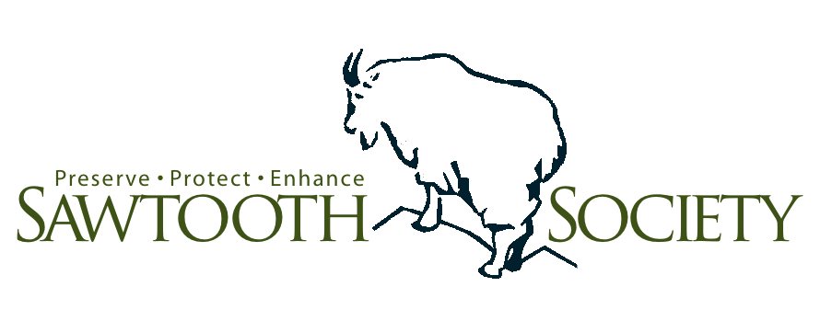
FOR IMMEDIATE RELEASE

Sawtooth Society announces new board members

April 2, 2013, Stanley, IDAHO—The Sawtooth Society is pleased to announce that Stanley, Idaho residents Amy Klingler and Melinda Hadzor have joined the Sawtooth Society’s board of directors.
“I live in Stanley year round, and I’m excited to have joined the Sawtooth Society board because the Society, among other activities, is engaging younger people and getting them into the outdoors,” said Klingler. “This is really important. I made a deliberate move to Stanley, it’s a small town that’s alive and well, where I’m fortunate to have my dream job.”
Klingler is a physician assistant and manager at the Salmon River Clinic in Stanley. She also serves on the editorial board of the Journal of American Academy of Physician Assistants, board of directors of the Idaho Academy of Physician Assistants [IAPA] and the executive committee of the Stanley School Parents Association. In 2012, Klingler was honored as the Idaho Physician Assistant of the Year by the IAPA.
“My mother started the emergency clinic in Stanley and she was a founding member of the Sawtooth Society,” said Hadzor. “I thought the legacy should continue. I have a real passion for the area as my roots run very deep here.”
Hadzor is co-owner of the Back Country Bistro and The Horseshoe Pit Catering Company in Stanley and also serves as general manager of the Stanley High Country Inn. In addition, Hadzor is the newest member of the Stanley City Council. Prior to living in Stanley, Hadzor spent 25 years with Ada County Courts working in several positions including as a certified probation officer, managing Ada County Juvenile Courts and working in various probation programs.
“As we have grown the Society board over the past four years to match the growing breadth and depth of Society programs, we recognize the need to maintain a diversified board; one with a wealth of different expertise and networks among its members and representatives of the communities we serve,” said Sawtooth Society President Paul Hill.
“The addition of Melinda and Amy to the board promotes these goals by strengthening Society involvement and contact with the younger generation of Sawtooth residents and visitors and the Stanley community—gateway to the Sawtooth NRA.”
The Sawtooth Society’s thirty-six member board of directors consists of individuals who live full-time or part-time in the Sawtooth and Wood River Valleys as well as members living around the country who believe in the preservation, enhancement and protection of the Sawtooth NRA. The Sawtooth Society is widely recognized as one of the most effective regional and national advocates for the Sawtooth NRA and the public policies that affect it.
“It’s an honor to have such accomplished and successful individuals join the Sawtooth Society board of directors,” said Sawtooth Society Executive Director Gary O’Malley. “Amy and Melinda’s expertise, interests and local knowledge as full-time Stanley residents will benefit the Sawtooth Society’s mission as well as its ability to continue the important work of the organization for everyone to fully appreciate and enjoy the Sawtooth NRA.”
The Sawtooth Society offers memberships, programs, grants and volunteer opportunities to benefit the area. Committed to enhancing everyone’s Sawtooth NRA experience, the Society has a number of upcoming volunteer project and donation opportunities for getting involved. Individuals and organizations can help the Society accomplish its aggressive efforts to help preserve, protect and enhance the Sawtooth National Recreation Area for future generations.
For details and more information, visit the Sawtooth Society’s new website www.sawtoothsociety.org.

